Problem Set 2
(100 points)

AI tools policy for problem sets: For problem sets, you may use AI tools (e.g. ChatGPT) to help brainstorm or to revise existing work you have written. When you submit your problem set, we expect you to clearly attribute what text was generated by the AI tool (e.g., AI-generated text appears in a different colored font, quoted directly in the text, or use an in-text parenthetical citation). While AI tools can provide helpful insights, we want you to think critically about the information you receive. We encourage you to ask specific questions, provide context, and evaluate the quality of the answers provided by AI tools. Remember, the answers are not always correct.

Problem 1. Coffee Demand (20 points)

You run a small coffee roaster and would like to predict what will happen to the quantity demanded for your coffee if you raise your price. While you do not know the exact demand curve for your coffee, you do know that in the first year, you charged a price of $45 and sold 1,200 units, and in the second year, you charged a price of $40 and sold 1,400 units. The economic environment (e.g., competition, income, etc.) were similar in the two years.

- (5 points) What is the implied own-price elasticity? Is demand elastic, inelastic or unit-elastic? Briefly discuss plausible reasons why demand is elastic or inelastic.
Use the formula for own-price elasticity:

$$E=\frac{\frac{ΔQ}{Q}}{\frac{ΔP}{P}}$$

Since

$$\frac{ΔQ}{Q}=\frac{1400-1200}{1200}=\frac{1}{6}$$

$$\frac{ΔP}{P}=\frac{40-45}{45}=-\frac{1}{9}$$

Then the elasticity (measured at the initial price-quantity pair) is:

$$E_{Q=1200 }=\frac{\frac{1}{6}}{-\frac{1}{9}}=-1.5$$

Thus, demand is elastic.

Note: As we said in class, we typically use the initial price and quantity as a reference point when computing the elasticity. This is what we did in the solution above.
In this case, demand is elastic probably because of (1) low product differentiation, since coffee is a relatively homogeneous product (think of cars, for instance, that can differ from each other in many more dimensions) and (2) high market fragmentation, since coffee is a global commodity and roasters face a highly competitive market with each producer holding a relatively small market share.

- (5 points) Based on your answer in question a): If you raise your price, will total revenues increase or decrease? If you change the price a second time, can you use the same elasticity from (a) to predict the exact new quantity demanded?
Since $E_{Q=1200 }=-1.5$, the firm is operating in the elastic portion of the demand curve. Thus, revenues will fall if the price goes up. If you change your price a second time you cannot use the same elasticity as before. This is because the elasticity changes as we move along the demand curve: At a different price-quantity point, the elasticity will be different.

- (5 points) Justify your answer in (b) and illustrate it graphically. You may use AI tools to produce graphs.

First, revenues will fall because $E_{Q=1200 }=-1.5$, so the firm is operating on the elastic portion of the demand curve. Second, if you change your price a second time you cannot use the same elasticity because the firm will be operating on a different point of the demand curve and the elasticity varies across the demand curve.

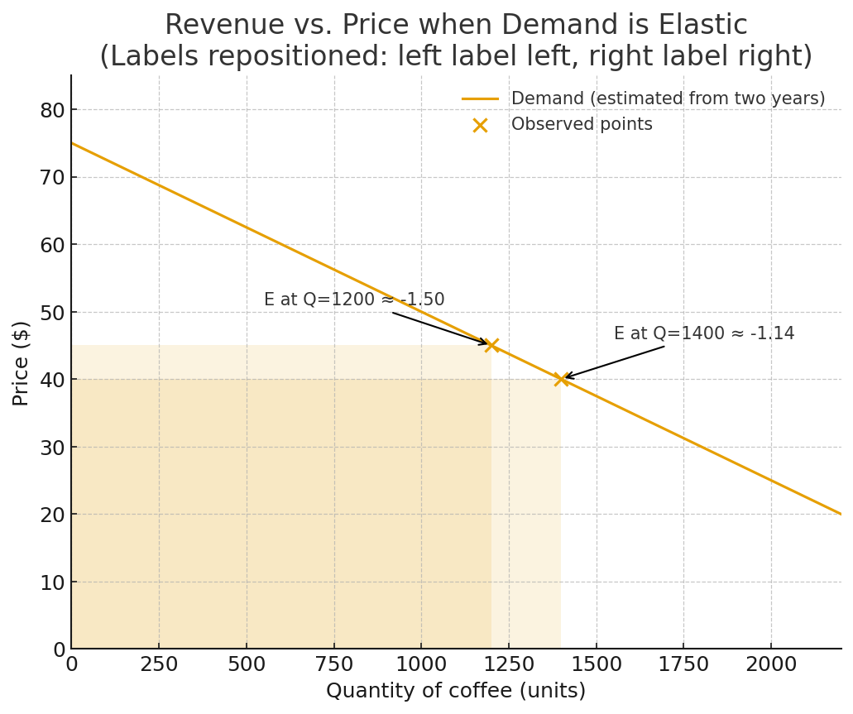

- (5 points) Assume that you maintained a price of $40 in the third year. However, your main competitor decreased its own price by 20% relative to the second year. Following this change, your sales dropped from 1,400 to 1, 260 units. What is the magnitude of the cross-price elasticity between your coffee and your competitor one? Does this seem rather elastic or inelastic to you? What could be the reasons? Think in particular of product differentiation.

Use the formula for cross-price elasticity (where X refers to your product and Y to the competitor’s product):

$$E=\frac{\frac{ΔQ_{X}}{Q_{X}}}{\frac{ΔP_{Y}}{P_{Y}}}$$
Since

$$\frac{ΔQ}{Q}=\frac{1260-1400}{1400}=-\frac{1}{10}$$

$$\frac{ΔP}{P}=-20\%=-\frac{1}{5}$$

Then the cross-price elasticity is:

$$E_{X,Y }=\frac{-\frac{1}{10}}{-\frac{1}{5}}=0.5$$

This cross-price elasticity seems relatively high (for example, compared to the 0.15 that we have seen for different types of cereals in class). This is also due to low product differentiation as we discussed in (a): coffee is a relatively homogeneous good, so customers view coffee from different producers as close substitutes. Although there is some differentiation in coffee quality/flavors, these differences are relatively subtle to most customers, and many roasters/producers can produce varieties of coffee that compete with each other at relatively similar quality levels.

Problem 2. Consulting for Dollar General and Apple (20 points)

- (10 points) The WSJ recently reported that Dollar General, a discount retailer, “has been trying to avoid passing along higher prices to its customers and has even reduced prices in some areas.”
  - Using concepts from class, discuss the anticipated effects of these price reductions on Dollar General’s quantity of goods sold and total revenue, holding everything else constant. [Note: There is no ‘right’ or ‘wrong’ answer. We want to evaluate your reasoning based on the economic concepts learned in class. You may use AI tools to produce graphs to explain your reasoning, but this is optional.]

Below we provide a sample response. Full credit will be given to answers that make reasonable assumptions regarding the elasticity of demand for Dollar General and predict the change in TR consistent with the assumptions.

Holding everything else constant, a reduction in prices is likely to lead to an increase in the quantity of goods sold due to the law of demand. However, the effect of the decrease in prices on total revenue is ambiguous. It depends on the elasticity of demand for their products. If demand is elastic at the initial price, a reduction in prices will result in a bigger increase in quantity, thus total revenue will increase. However, if the demand for their products is inelastic, the increase in quantity is smaller, thus not enough to offset the decrease in prices. Total revenue in this case will fall. If the demand is unit-elastic, total revenue is likely not to change much. Since Dollar General sells everyday products that customers could find at many other retailers (Walmart or any convenience store), we would expect its demand elasticity to be relatively high. In addition, the typical Dollar General customer is likely cost conscious and willing to shop around for low prices. So a price decrease would likely result in an increase in total revenue.

Finally, note that if Dollar General is the only store that does not raise prices, then the effects are essentially the same as when it’s the only store that lowers prices. So you could also make the above argument focusing on the relative prices of Dollar General vis-à-vis its competitors.

  - Discuss whether a simultaneous price reduction at Walmart would alter the anticipated effects on quantity that you described in (1).

If Walmart also reduces their prices at the same time, the demand curve that Dollar General is facing is likely to shift inward (move to the left), since these two stores sell many substitute products and serve a similar market segment (price-sensitive customers). Therefore, the quantity of goods sold by Dollar General could either increase or decrease, depending on which effect prevails (the effect of Dollar General’s own price reduction, explained in part 1, or the effect of the competitor’s price reduction).

- (10 points) Apple is contemplating raising the price of the Apple Music “Individual” Plan. Before doing so, Apple would like to estimate the effects of a price increase on the number of subscriptions sold. Suppose that Apple has enlisted your help with this task.
  - Using concepts from class, discuss three methods to estimate the effect of a price increase on the number of subscriptions sold.
- Survey customers: Apple can survey their customers to get a sense of how likely they would be to cancel/keep the subscription if the price increased by $X.
- Transaction data: Apple has data on its customers’ past purchases. Using these data, Apple can run a regression analysis. The independent variables can include not only prices, but also other factors that could affect the quantity sold such as characteristics of customers (age, gender, etc.), or whether users have other Apple products, etc. Using the regression results, they can estimate the change in Q in response to the change in price of the Apple Music “Individual” Plan.
- Market experiment (A/B Testing): Apple could conduct an experiment in which they change the price for a segment of the market. The response of that group compared to the other group can help estimate the change in the number of subscriptions sold.

  - Weighing the costs and benefits of the three approaches, which one would you recommend for Apple? Why? [Note: There is no ‘right’ or ‘wrong’ answer. We want to evaluate your reasoning based on the economic concepts learned in class.]

Below we provide a sample response. Full credit will be given to answers that make reasonable assumptions regarding the feasibility, costs, and benefits of the method of estimating demand.

Surveys could give Apple an instant, low-cost estimate of the effects of the price increase. Since Apple is a well-known company with a broad customer base, it should be straightforward to reach out to customers to conduct surveys. However, sometimes customers’ responses do not truthfully reflect what they would do in real life. Apple should also be concerned about sampling bias: the customers who respond to the survey may not represent their (potential) customers as a whole.

One advantage of using transaction data is that Apple already maintains such data in-house, which will save Apple money compared to running a survey. However, it is hard to capture every factor that could potentially affect the quantity of subscriptions. There are numerous non-price factors that could affect demand, including seasonality, changing consumer preferences, and changes in the prices of competitor music streaming services. Also, customers’ past purchases of other Apple products may not accurately predict their future purchases of the Apple music plan.

A market experiment is likely the most accurate way to estimate the change in subscriptions sold due a price increase. This would be our recommendation. The online setting enhances the feasibility of randomizing prices. When signed into their Apple account, new customers could be randomly assigned the higher price or the current price. Apple could then observe the purchase decisions of new customers (while grandfathering all existing customers into the old price). Even though market experiments could potentially give the best estimate, this method could pose some challenges. It could be costly to run an experiment and to make sure the experiment is run correctly. If the process of assigning control and treatment group is not random and done correctly, the experimental results would not be informative. In addition, the experiment described above would only be informative for new customers, not existing customers. Finally, if Apple randomizes prices for its service and customers find out they paid different prices for the same service, it could lead to consumer backlash.

Problem 3. Air Travel Demand Elasticity (15 points)

The following data were collected to show the impact of a recent price war during which all the airlines serving the Oakland/Burbank market lowered their prices. You may assume that all other factors affecting air travel demand remained unchanged.

Your assignment is to calculate the implied (own-price) elasticity of demand for overall air travel between Oakland and Burbank.

All numbers are measured on a per-month basis.
Passengers before price war | 246,555
Passengers during price war | 1,053,139
Increase in passengers | 806,584
Average one-way fare before price war | $86.50
Average one-way fare during price war | $44.69
Decrease in one-way fares | -$41.81
Market revenue before price war | $21,327,008
Market revenue in during price war | $47,064,782
Increase in market revenue | $25,737,774

- (10 points) What is the own-price elasticity of demand? Is air travel demand between Oakland and Burbank elastic or inelastic?

Use the definition of elasticity and plug in the values:

$$E_{d}=\frac{\frac{Q_{2}-Q_{1}}{Q_{1}}}{\frac{P_{2}-P_{1}}{P_{1}}}=\frac{\frac{1,\text{053},\text{139}-\text{246},\text{555}}{\text{246},\text{555}}}{\frac{\$\text{44.69}-\$\text{86.50}}{\$\text{86.50}}}=\frac{\text{3}\text{.}\text{2714}}{-0.\text{4833}}=-6\text{.77}$$

Quantity demanded increased by 327%, while the price dropped by 48.33%.

This implies that demand is elastic – the response in quantity demanded is proportionately stronger than the change in price

- (5 points) Do you expect the own-price elasticity of demand on the Oakland–LAX route to be larger in magnitude, smaller, or about the same as the elasticity you estimated for Oakland–Burbank? Briefly justify your answer using economic concepts. [Note: There is no ‘right’ or ‘wrong’ answer. We want to evaluate your reasoning based on the economic concepts learned in class.]

Below we provide a sample response. Full credit will be given to answers that choose either airport and that make reasonable assumptions regarding the determinants of demand elasticity.

The ranking is ambiguous and depends on which forces dominate:

- Argument for LAX more elastic: LAX is a much larger airport, with more carriers and higher frequency, which expands same-day/time substitutes and intensifies price competition → can make OAK–LAX more elastic.

- Argument for BUR more elastic: If Burbank attracts a more price-sensitive customer segment that travels mostly on low-cost airlines, while business/wealthier (less price-sensitive) travelers prefer LAX. Also, LAX offers international connections, so people traveling abroad will prefer to use LAX and will thus be less elastic (reluctant to switch airports).

Problem 4. Aircraft Demand (20 points)

Boeing’s new aircraft has the following demand:
$$Q=250-P$$

where price P is in millions of dollars.

- (5 points) How many units will Boeing sell at a price of $140 million? Show your work.

Plug in the price to find the corresponding quantity:

$$Q=250-P=250-140=110$$

- (10 points) Calculate the marginal revenue at the price of $140 million.

First, solve the demand function for P:

$$Q=250-P⇒P=250-Q$$

Second, compute total revenue:

$$TR=Q×P=Q×\left(250-Q\right)=250Q-Q^{2}$$

Third, take the derivative of total revenue with respect to Q to get MR:

$$MR=\frac{dTR}{dQ} =250-2Q$$

Finally, plug the quantity corresponding to a price of $140 million (from part a) into MR:

$$MR =250-2Q=250-2×110= 30$$

- (5 points) For prices between 100 and 200 million, plot the number of airplanes sold. What is this curve? You may use AI tools to produce graphs.

It is the demand curve for Boeing’s new aircraft.
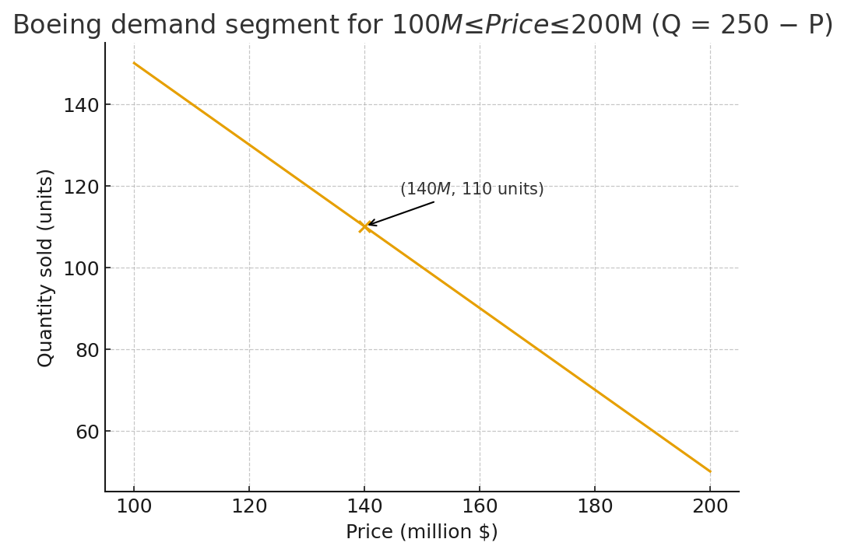

Problem 5. Lyft Demand (25 points).

An analyst at Lyft initiated an empirical estimation of demand for Lyft trips in Boston. The analyst ran a price experiments in the Boston area, by randomizing the price charged for different routes. She then assembled data on the quantity of trips taken, depending on the different prices that Lyft charged. The analyst also collected data on the price charged by Uber, Lyft’s main competitor, at the time when the Lyft trips took place. Hence, for each route, she observes the quantity of trips taken, Lyft price, distance, and price of Uber.

Suppose that the analyst has run one multi-variate linear regression of the following form:
Q = b₀ + b₁P + b₂PX + b₃Y
Where:
- Q is the number of Lyft trips taken
- P is Lyft’s price in dollars
- PX is Uber’s price in dollars
- Y is the distance in miles

As you will find out in your Stats class, the estimated regression coefficients are as follows:

b₀ = 67.4
b₁ = -16.0
b₂ = 2.6
b₃ = 39.3

yielding the following demand equation:

Q = 67.4 - 16.0P + 2.6PX + 39.3Y

Note: You do not need to perform the estimation for the Econ class.

- (5 points) Use the regression results to estimate the number of Lyft trips taken under the following assumptions:

  - P = $13.2
  - PX = $20.3
  - Y = 3.8

Plug in the values for P, PX and Y in order to compute quantity, Q:

Q = 67.4 – 16$×$13.2 + 2.6$×$20.3 + 39.3$×$3.8 = 58.32

- (7 points) Calculate the own-price demand elasticity under the above conditions at a Lyft price of $13.2. Is demand elastic, inelastic or unit-elastic?
From the elasticity formula:
$$E=\frac{ΔQ}{ΔP}×\frac{P}{Q}$$

From the regression, we know that the slope of the demand function is:

$\frac{ΔQ}{ΔP}$ = -16
We know that:

$P=13.20$
$$Q= 58.32$$

Then, plugging in into the elasticity formula,

$$E_{D}= -16×\frac{13.2}{58.32}=-3.6$$

Demand is elastic.

- (13 points) Calculate marginal revenue under the above conditions at a Lyft price of $13.2.
From the regression equation we can obtain an expression for Q that only depends on P under the above conditions

Q = 67.4 – 16$×$P + 2.6$×$20.3 + 39.3$×$3.8

$$Q=269.52- 16×P$$

Solving for P:

$$\frac{269.52- Q}{16} =P$$
Total revenue can be written as:

$$TR=P×Q=\left(\frac{269.52- Q}{16} \right)×Q =\frac{269.52Q-Q^{2}}{16}$$

Taking the derivative with respect to Q, we can obtain MR:

$$MR=\frac{269.52}{16}-\frac{2}{16}Q$$

From part a., if $P=13.20$, $Q=58,32$. Then:

$$MR=\frac{269.52}{16}-\frac{2}{16}×58,32$$
$$MR=9.55$$

